

OROMIA STATE UNIVERSITY

COLLEGE OF SCIENCE AND TECHNOLOGY

DEPARTMENT OF INFORMTION TECHNOLOGY

**Mobile Assisted Maternal Health Advisory System for Batu Health Center**

BY

NAME ID

1. Lense Adugna………………………. PIT/R/13/01009
2. Aseggedech Deressa ………………...PIT/R/13/01001
3. Gebi Kedir…………………………...PIT/R/13/01004

Project Advisor: Ins. Yigermal Semahegn.

Oromia State University, Batu, Ethiopia

MAY 20, 2024

# Approval Form

This is to confirm that the project proposal entitled Mobile Assisted Maternal Health Advisory System submitted to: Oromia State University, Collage of Science and Technology Department of Information Technology  
by:

1. LENSE ADUGNA……………………….PIT/R/13/01009
2. ASEGGEDECH DERESSA……………. PIT/R/13/01001
3. GEBI KEDIR…………………………….PIT/R/13/01004

.

-------------------------------------------- ------------------------------ ----------------------  
Advisor Name Signature Date

TABLE OF CONTENTS

Approval Form ii

ABBREVIATIONS vii

ABSTRACT viii

CHATER ONE 1

INTRODUCTION OF THE APPLICATION 1

1.1 Introduction 1

1.2 Background 1

1.2.1 Background of the Organization 1

1.2.2 Mission 1

1.2.3 Vision 1

1.2.4 Core values 1

*1.2.5*Organization Structure 2

1.3 Statement of Problems 3

1.4 Objective 3

1.4.1 General objectives 3

1.4.2 Specific Objectives 3

1.5 Proposed of the System 4

1.6 Scope and Limitation 4

1.6.1 Scope 4

1.6.2 Limitations 4

1.7 Beneficiaries of the Application 5

1.8 Significance of the Application 5

1.9 Methodology 5

1.9.1 Data collection Tools/Techniques 5

1.9.2 System Analysis and Design 5

1.9.3 System Development Model 5

1.9.4 Development Environment and Tools 6

1.9.5 Testing methodology 6

1.9.6 Deployment Method 7

1.10 Feasibility study 7

1.10.1 Economic feasibility 7

1.10.2 Technical feasibility 7

1.10.3 Time feasibility 7

1.10.4 Operational feasibility 8

1.11 Project Plan 8

1.12 Team Composition 10

LIST OF FIGURES

Figure 1: Organization Structure 2

Figure 2 : Iterative Model 6

Figure 3: Time Schedule 8

LIST OF TABLES

Table 1: Development Environment Tools 6

Table 2: Hardware Requirement Cost 9

Table 3: Software Requirement Cost 9

Table 4: Team Composition 10

# ABBREVIATIONS

PHC……………………………………….Public Health Service

VIS………………………………………..Vaccine Information Statement

HRM………………………………………Human Resource Management

CDC……………………………………….Center of Disease Control

ART……………………………………….Antiretroviral Treatment

MCH……………………………………….Maternal and Child Health

ANC……………………………………….Anti Natal Care

GUI………………………………………..Graphical User Interface

XML……………………………………….Extensible Markup Language

RAM……………………………………….Random Access Memo

# ABSTRACT

*This project proposal outlines the development of a mobile-assisted maternal health advisory system for Batu Health Center. The system aims to provide essential information and facilitate communication between mothers and healthcare professionals. It addresses issues such as limited access to healthcare services and high maternal morbidity and mortality rates. The objectives include designing a database, implementing the system, developing an interactive GUI, conducting a study, and identifying stakeholders. The system will offer features such as chat-based consultations, symptom identification, medication reminders, and appointment scheduling. It has limitations, requiring an internet connection and physicians cannot prescribe medications through the system. Beneficiaries include mothers, healthcare professionals, and family planning workers. The project methodology involves data collection, system analysis, and design. Overall, the project aims to improve accessibility and effectiveness in addressing maternal health challenges at Batu Health Center through a mobile-assisted advisory system.*

# CHATER ONE

# INTRODUCTION OF THE APPLICATION

## 1.1 Introduction

Mobile assisted maternal health advisory system is simply a mobile application that helps mothers or physician to get necessary information about maternal health and perform communication between mothers and physician or family planning workers. Typically, this application is exceedingly useful for a mothers or physician when they are far from each other and busy.

## Background

### 1.2.1 Background of the Organization

Batu Health Center was established in 1953 by the Oromia Health Bureau and consists of seven Board members. The board is headed by the office of the mayor of Batu. Although nothing is known about how many employees the Batu Health Center started when it was established, it currently has sixty eight (68) employees including two (2) Doctors, one (1) MPH, seven (7) Ho, BSC Nurse three (3), eight (8) Clinical Nurse, three (3) Laboratory, three (3) Midwives, three (3) Pharmacy, one (1) Anesthetic, and thirty-seven (37) support staff for Administration is currently providing timely and accessible services to the local community.

### 1.2.2 Mission

Batu Health Center is a comprehensive democratic and un-integrated health system, providing quality and efficient health services such as disease, health promotion and medical services, in coordination with stakeholders to prevent disease, reduce morbidity and mortality.

### 1.2.3 Vision

It is to create a healthy community of the city that can play its role by participating in development.

### 1.2.4 Core values

* Prioritizing the community
* Transparency.
* Responsibility.
* Work in coordination.
* Equity.
* Be prepared for change
* Confidentiality and honesty.
* Participation.
* Good example.
* Rule of law.
* Maintaining Professional Ethics.

### 1.2.5Organization Structure

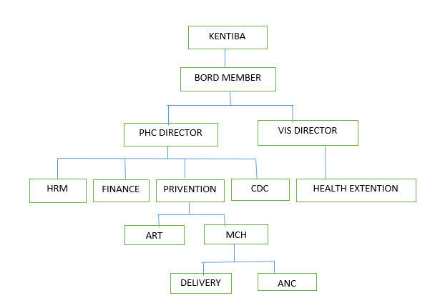

Figure 1: Organization Structure

## 1.3 Statement of Problems

The major determinants of maternal morbidity and mortality include pregnancy, the development of pregnancy-related complications, including complications from abortion and, the management of pregnancy, delivery, and the postpartum period. However, a lot of factors contribute to the low health status of women in the developing countries including Ethiopia. These factors include:

* Socio economic development of the country has serious Impact on morbidity and mortality.
* Access to health services:-Lack of access to modern health care services has great impact on increasing maternal death. Most pregnant women do not receive antenatal care; deliver without the assistance of trained health workers etc. Less than 10% of women in Ethiopia and many countries of Africa & Asia get Family planning services.
* Women’s reproductive and health behavior:- Reproductive and health behavior involves, for example, the age at which a woman becomes pregnant, whether the pregnancy is wanted, and what kind of health care the woman seeks

Due to the above factor:-

* Most pregnant women do not receive antenatal care.
* Maternal mortality and unnecessary pregnancy increased.
* Time and cost wastage to get health centers
* Women often lack access to relevant information, trained providers and supplies, and other essential services.
* Poorly timed unwanted pregnancies carry high risks of morbidity and mortality, as well as social and economic costs, particularly to the adolescent and many unwanted pregnancies end in unsafe abortion.

## 1.4 Objective

### 1.4.1 General objectives

The general objective of this project is to develop a mobile assisted maternal health advisory system for Batu-Health Center

### 1.4.2 Specific Objectives

The following are the specific objective of maternal health advisory system

* To design interactive GUI using XML
* To implement the proposed system
* To Design a database Batu-Health Center
* To establishing a maternal health counseling system supported by mobile phones
* To develop and to implement a system that is efficient and reliable.
* To provide alternative solutions.
* To evaluate the existing paper-based information.

### 1.5 Proposed of the System

The Mobile Assisted Maternal Health Advisory System for Batu Health Center is designed for any health center to replace their existing manual paper based system. The new system aims to provide essential information and facilitate communication between mothers and health care professionals and it also addresses issues such as limited access to healthcare services and high maternal morbidity and mortality rates. These services are to be provided in an efficient, cost effective manner, with the goal of reducing the time and resources currently required for such tasks.

## 1.6 Scope and Limitation

### 1.6.1 Scope

This project will help mothers by providing required information.

* Registers Mothers
* Allow admin to upload information
* Get detail advice and recommendation from physicians
* Allow to view mother her information
* Allow to view mother her appointment

### 1.6.2 Limitations

* The system will not work unless network connection is available at the time
* The system will not work unless the user device has enough balance to access internet.
* The physician will not prescribe a medicine to mothers but they will make them aware about their problem and make them to visit close health station

## 1.7 Beneficiaries of the Application

* The internet connection is available Help women to talk/contact physicians from distance without physical contact.
* Help Family Planning workers get necessary information over their mobile where ever

## 1.8 Significance of the Application

After this project is finished and properly used the proposed Mobile assisted maternal health advisory system gives great significance and it increases the efficiency and effectiveness of the system. Some of the significances that the project will considers are listed out as follows:

* Automatically generate the reports
* Reduce time, cost and redundancy of information or data.
* Improving efficiency, control and security of existing system.
* It provides accurate output and fast answer of queries.

## 1.9 Methodology

### 1.9.1 Data collection Tools/Techniques

For the collection of data we used observation, interview and literature view.

* Observation: - We have observed the existing system. We observe Batu Health Center how they assist maternal health.
* Interview:-we used interview to get information about existing system for developing our project.
* Questioner: we used questioner to get information about existing system for developing our project.

### 1.9.2 System Analysis and Design

We are going to model the requirements that we gather using object oriented approach because Object oriented technology is of broad means used to handle highly structured applications. Object oriented technology provides numerous advantages in applications by making them easy to use and maintain.

### 1.9.3 System Development Model

The proposed system use an iterative model for the development of a Mobile Assisted Maternal Health Advisory System. The iterative model offers several positive aspects in this context. It allows for flexibility and adaptability, enabling incremental changes and updates based on feedback and evolving requirements. In designing the proposed system for Batu Health Center Mobile assisted maternal health advisory system.

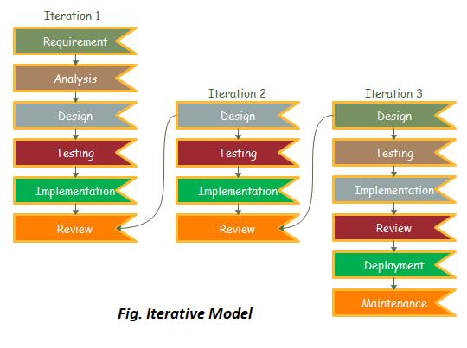

Figure 2 : Iterative Model

### 1.9.4 Development Environment and Tools

|  |  |
| --- | --- |
| Activities | Tools and Programs |
| Frontend | XML, Java, Kotlin |
| Backend | SQLite |
| Documentation | MS Word, Sniping tool, PDF, Edrawmax, GanttChart |
| Deployment Environment | Play Store |

Table 1: Development Environment Tools

### 1.9.5 Testing methodology

We have performed different testing for checking functionality of our proposed system:-

* Unit testing: first we will test each unit at each system, so if a problem is encountered it will immediately maintain at which the problem is occurred.
* Integration testing: after we test each unit of the proposed system we will perform and integration test to check whether the system meets all the functional requirements. When a number of components are complete, it will test to ensure that they integrate well with each other, the operating system and other components.
* System testing: after all of the above testing is checked we will test our system by other peoples and we will conduct some comments how they get our system.

### 1.9.6 Deployment Method

This system is developed for Batu Health Center to Advice mothers. We understanding the health problems faced by mothers, motivated us to develop this system for the Batu Health Center so that mothers can easily communicate with the health professional on their mobile phones.

## 1.10 Feasibility study

Since Mobile assisted maternal health advisory system is very useful for the mothers in that it provides different information in their health, it is expected that this application system will also grow faster and more productively if mothers or physicians recognize the role of strategic financing from the system and interventions in to using it. This application simplifies their work by providing much functionality.

### 1.10.1 Economic feasibility

The development cost is one of the affecting factors of which results in inefficiency of the new system. On the current system users get the problem of cost in different situations. This means the proposed system should be economically feasible to reach its desired goal. In addition the developing materials are freely available the only thing the user requires is that mobile phone. As all the resources are already available, it give an indication of the system is economically possible for development

### 1.10.2 Technical feasibility

The technical issues that are involved in the system such as the normality and strength of the mothers mobile from the hardware part, the software should work properly in the proper inputs from its users from both user and the software point of view should be considered to determine the feasibility. There are also other services provided from the mobile for which we don’t need to rebuild it again. Additionally, in simple terms long range portable mobile device required for the betterment of the application usage.

### 1.10.3 Time feasibility

Time feasibility is the most important and superior thing to be considered. The period of time considered as a resource under user control and sufficient to accomplish some work and it is an instance or single occasion for some work. This system is feasible by time since it reduces the time required to work through with physical contact.

### 1.10.4 Operational feasibility

The user should not misuse the system. To determine the operational feasibility of the system we should take into consideration the knowledge level of the users. Initially this system is proposed to be designed to who use mobile phone. The application is expected to be very flexible for its users. And this is also one of the factors that make it operationally feasible.

## 1.11 Project Plan

A. Schedule

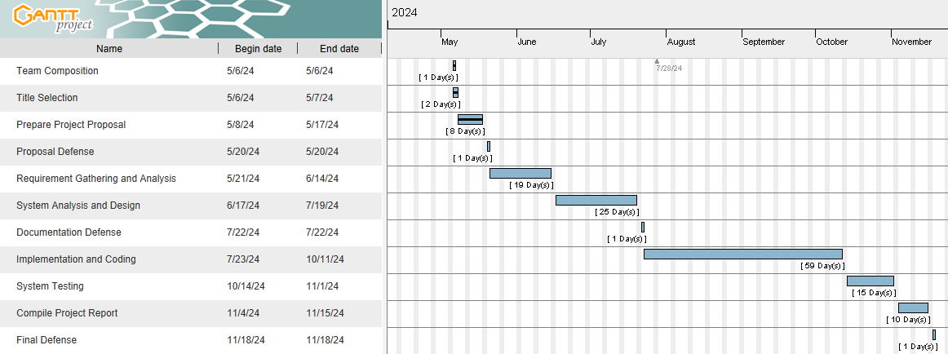

Figure 3: Time Schedule

B. Budget

* Hardware Requirements cost

|  |  |  |  |  |
| --- | --- | --- | --- | --- |
| No | Materials Required | Amount | Price Per Unit | Total Cost |
| **Material** | | | | |
| 1 | Printing document | 100 | 5 | 500 |
| 2 | Pen | 5 | 25 | 125 |
| 3 | Paper | 1pack | 800 | 800 |
| **Hardware** | | | | |
| 1 | Flash Disk | 32Gb | 450 | 450 |
| 2 | Laptop | I core 5 | 52,000 | 52,000 |
| 3 | RAM | 8Gb | 2000 | 2000 |
| Total 55,875 | | | | |

Table 2: Hardware Requirement Cost

* Software Requirements Cost

|  |  |  |
| --- | --- | --- |
| **No** | **Software Required** | **Price Per Unit** |
| 1 | Microsoft Word 2013/2010 | Free |
| 2 | SQLite | Free |
| 3 | Mozilla Firefox | Free |
| 4 | Windows 10 OS | Free |
| 5 | Edrawmax | Free |
| 6 | Android Studio | Free |
| Total Free | | |

Table 3: Software Requirement Cost

## 1.12 Team Composition

|  |  |  |  |  |
| --- | --- | --- | --- | --- |
| Project Title | Mobile assisted maternal health advisory system | | | |
| Prepared By | NAME | EMAIL/PHONE | | Responsibility |
| 1. Lense Adugna | lenseadugna@gmail.com | 0919576405 | All activity |
| 2. Aseggedech Deressa | aseggedechderessa@gmail.com | 0932278930 | All activity |
| 3. Gebi Kedir | gebikedir71@gmail.com | 0922144171 | All activity |
| Date | 12/09/2016 | | | |
| Advisor | Ins.Yigermal Semahegn | | | |

Table 4: Team Composition

Conclusion

This proposal the development of a mobile-assisted maternal health advisory system for Batu Health Center. The system aims to improve access to healthcare services and communication between mothers and healthcare professionals. With features designed to provide guidance and support, the system has the potential to empower mothers and contribute to better health outcomes. The project's feasibility study indicates its viability, and the proposed project plan outlines clear milestones for successful implementation. By leveraging technology and collaboration, the system can make a positive impact on maternal health at Batu Health Center, aligning with the organization's mission of creating a healthy community.

Reference

1. <https://www.google.com.et/#q=LN_maternal_care_final+pdf>
2. <https://poe.com/chat/2b29fj4g83g3c50siia>
3. MOH: National Reproductive Health Strategy 2006 - 2015. Federal Democratic Republic of

Ethiopia, Ministry of Health.: Addis Ababa, Ethiopia; 2006.

Questioner

1. What is the background of the organization?
2. What is the current system?
3. Is there any special help for mothers in the organization?
4. What are the strengths and weaknesses of maternal health care delivery?